Mrs. Legner

Fifth Grade

Mrs. Legner

Fifth Grade

- Welcome to Our Classroom
- What you can expect from me as the teacher!
- My expectations from my students☺
- Grading

- Absences

- Homework Expectation

- Daily Responsibility Check

- Field Trip

- How Parents Can Help Their Children Learn
Welcome to Our Classroom!
I am excited to be your child’s teacher this year☺ I look forward to working with you to make this the best year possible for your child.

What You Can Expect from Me:
- You can expect me to respect each student as a unique individual.
- You can expect me to provide an appropriate classroom environment.
- You can expect me to teach the St. Mary’s School/Common Core Curriculum.
- You can expect me to emphasize the importance of Language Arts, Math, and Social Science in daily life.
- You can expect me to keep grades current by updating them weekly in our FACTS system.
- You can expect me to be available to discuss any concerns you may have.
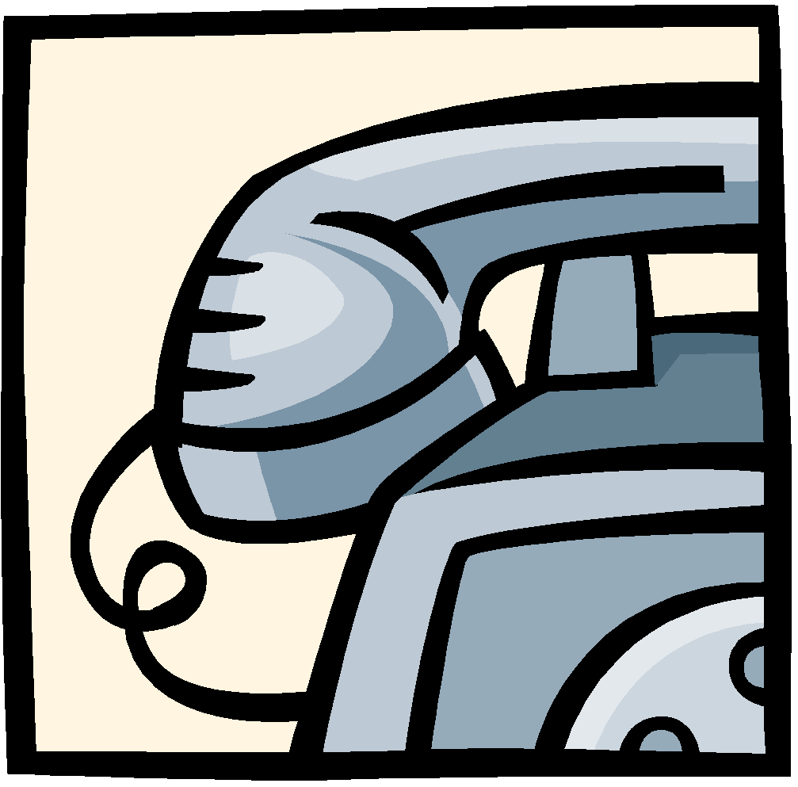
- You can send a note to school
- Email: legner.heidi@stmaryspontiac.org
- Call me at school 815-844-6585
- Call me on my cell at 815-579-0446

My Expectations:
- I expect all students to follow class rules and to participate in class.
- I expect all students to come to school prepared everyday.
- I expect all parents to encourage their child to follow rules/guidelines.
- I expect all parents to let me know if there is anything I can do or implement to better educate their child.

Grades
Students receive letter grades in Fifth Grade. The grading scale is as follows:
A 94-100
B 86-93
C 76-85
D 68-75
F Below 68
Letter grade will be given on daily work, weekly spelling/vocabulary tests, quizzes, tests, and other types of assessments.
Absences
If your child is absent, please remind them to get their missing work when they return. They will have one day for every day absent to make up any work that they missed. If they turn their absent work in after the given amount of time, it will be considered late. Please see the school handbook for late work policies.

Homework Procedures
Homework may be assigned Monday through Friday. It should take no longer than an hour to complete, including their daily reading of 20 minutes. Each student is expected to bring completed homework to school daily.

Homework Folders
Each student has a plastic folder for homework assignments, parent letters, and mail from mailboxes. Please be sure to ask your child for their homework folder daily.
Daily Homework
Daily homework assignments are due the following day. Any assignment not turned in, will be considered late. Please see the school handbook for late work policies.

Weekly Homework
The only consistent weekly homework that the students will have is a reading log. Signed reading logs are due every Monday. As long as your child is reading 20 minutes every night and they hand in their reading log signed by an adult on Monday, they will receive an A+ for this weekly assignment. Any reading logs not handed in on Monday will receive a late grade. Please see the school handbook for late work policies. Reading logs not turned in at all, will receive a zero.

Quarterly Homework
Every student will be expected to complete 2 AR books at their reading level each quarter. After reading their book, they will complete an AR test on that book. This score will go in FACTS as a grade. One book/test will be recorded the first half of the quarter and the second book/test will be recorded the second half of the quarter. If your child takes multiple AR tests a quarter, they will receive the highest score of their tests for this requirement. These dates can be found in Google
Classroom - Literature. Novels we read in class DO NOT count as meeting this requirement.

Daily Responsibility Checks
To begin getting ready for Jr. High, the students will receive responsibility checks as soon as they enter the classroom from announcements. Your child will receive daily checks if they are prepared. These checks will be added to a subject of their choice at the end of the quarter. This is an easy way for them to earn “extra” points, but it also helps with accountability. In 5th Grade, we really work on holding each other accountable. The following items will be part of the daily responsibility check: Correct School Uniform, including a belt; all materials(books, papers, writing utensils, etc.) needed for the day, including their PE uniform/Art smock; and homework is handed in on time. This is not a penalty, but rather an opportunity for each and every student.

**I don’t believe in “extra credit,” so this is the only way they can earn “extra” points throughout the school year.

Field Trips

Fall Field Trip - This field trip is NOT every year. When the Illinois Extension Office hosts the Ag Day at the 4H Fair Grounds, we usually attend. Transportation is provided by Pontiac School District. Chaperones vary depending upon, the availability of seats on the bus, the number of students attending, and the number of classes attending. If there are aides going with multiple classes, we will need less parent chaperones.

Winter Field Trip - This field trip takes place every year on the Tuesday after President’s Day. Chaperones for the following year are chosen in February when we return from our field trip. The facility likes to have numbers and names of chaperones almost a year ahead of time. Transportation will be a bus provided by Pontiac School District. This field trip is at the expense of the parents, unless we are given a donation.

Spring Field Trip - This trip is a gift from CAT. They pay for the Challenger Program, transportation to get to and from, as well as a Subway boxed lunch. 5th and 6th Grade teachers are the only chaperones needed for this trip. The Challenger only allows two adults to attend with the students. This is their rule, not ours. We start really embracing this gift the second half of the year with activities that lead up to it.

**We may slip in a few walking field trips throughout the year as well. These will be curriculum based and won’t need chaperones.

How Parents Can Help Their Children Learn

- Help your child learn responsibility by being accountable for homework each night.
- Help your child get a library card from your public library. Find out from the children’s help desk if there are special programs for your child.
- Look through your child’s schoolwork with him/her. Let your child tell you about their work. Perhaps your child can make a scrapbook at home with samples of his/her best work.
- Practice 5 math multiplication facts each day.
- Help your child do a research project.
- Listen to your child read aloud.
- Read to your child. Children of all ages enjoy hearing stories.
- Establish a reading time for your child such as after dinner or before bed.
- Read the comics’ section of the newspaper with your child.
- Help your child select television shows to watch.
- Watch a television show together, then discuss/evaluate the show.
- Show your child the location of your home on a map.
- Play a board game with your child.
- Help your child start a collection of rocks, stamps, pressed leaves, etc.
- Give your child his/her very own calendar.
- Write notes to your child.
- Help your child write notes and letters to relatives/friends.
- Allow your child to subscribe to a children’s magazine.
- Help your child cook something.

